**CTF Challenge: Blockchain Security**

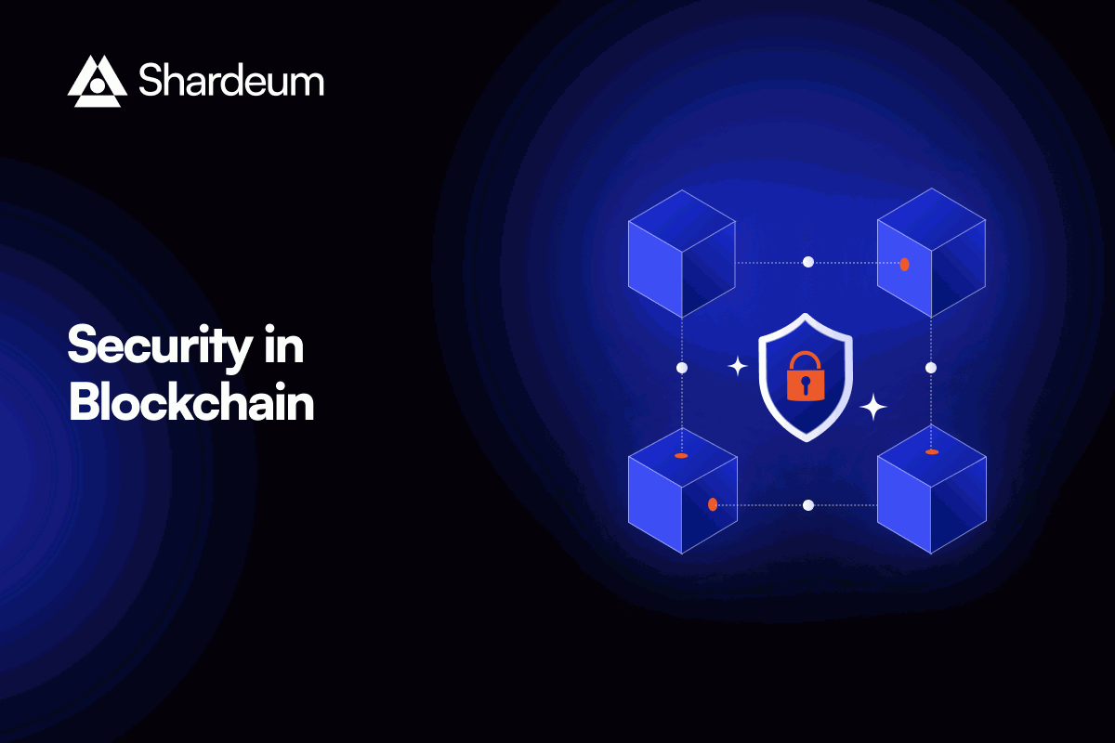

**Blockchain Security?**



Blockchain security refers to the set of measures, protocols, and practices implemented to protect blockchain networks, transactions, and decentralized applications (DApps) from various threats, vulnerabilities, and unauthorized access. Blockchain, as a distributed ledger technology, introduces unique security challenges and requires specialized approaches to ensure the integrity, confidentiality, and availability of data and transactions. Here’s an overview of key aspects of blockchain security:



1. **Cryptography**:
   * **Hashing**: Blockchain uses cryptographic hashing algorithms (e.g., SHA-256) to create digital fingerprints (hashes) of data blocks. These hashes ensure data integrity and immutability, as any alteration in the data would change the hash value.
   * **Digital Signatures**: Each transaction in a blockchain is signed with a digital signature, which provides authentication and non-repudiation, ensuring that transactions are authorized by legitimate participants.
   * **Encryption**: Some blockchain platforms support data encryption to protect sensitive information, ensuring that only authorized parties can access encrypted data.
2. **Consensus Mechanisms**:
   * **Proof of Work (PoW)** and **Proof of Stake (PoS)** are popular consensus algorithms used in blockchain networks to achieve agreement on the state of the ledger among decentralized nodes. These mechanisms prevent double-spending and ensure the validity of transactions through computational puzzles (PoW) or staking (PoS).

3. **Smart Contract Security**:

* + Smart contracts are self-executing agreements with predefined rules stored on the blockchain. Vulnerabilities in smart contract code can lead to exploits and financial losses (e.g., The DAO hack). Auditing smart contracts for security flaws, code quality, and logic errors is crucial to mitigate risks.

4. **Network Security**:

* + **Decentralization**: Blockchain’s decentralized architecture enhances resilience against single points of failure and DDoS attacks by distributing data and transaction validation across multiple nodes.
  + **Peer-to-Peer Network**: Securing communication between nodes using encryption and peer authentication mechanisms to prevent eavesdropping, tampering, and network-level attacks.
  + **Firewalls and Access Controls**: Implementing network-level security measures, such as firewalls and access controls, to protect nodes from unauthorized access and malicious activities.

# **Capture the Flag (CTF) Challenges**

**Flag 1. What type of algorithms are PoW and PoS in blockchain?**

Answer: Consensus

**Flag 2. What ensures data integrity in blockchain using cryptographic techniques?**

Answer: Hashing

**Flag 3. What technology protects transactions from unauthorized access in blockchain?**

Answer: Encryption

**Flag 4. What prevents alteration of transactions and provides authentication in blockchain?**

Answer: Signatures

**Flag 5. What kind of agreements are stored on the blockchain with predefined rules?**

Answer: Smart contracts